TASK-2 Report
MULTI-PAGE WEBSITE WITH CONTACT FORM

1. Student Details
- Name: Apoorva Reddy
- College: (Your College Name)
- Branch: B.Tech
- Year: Final Year
- Internship: Full Stack Web Development Internship

2. Project Title
Multi page website

3. Introduction
Web development is an important skill used to create websites and web applications. In this task, a multi-page website was developed using HTML, CSS, and JavaScript. The website consists of different pages connected through a navigation menu. It also includes a contact form with validation to ensure users enter correct information before submitting.
The main purpose of this project is to understand how multiple web pages work together and how JavaScript can be used to validate user input.

4. Objective
The objective of this project is:
- To create a responsive multi-page website.
- To understand page navigation using HTML links.
- To design attractive web pages using CSS.
- To implement a contact form.
- To perform form validation using JavaScript.
- To learn project hosting using GitHub.

3. Software and Tools Used
    - HTML5
    - CSS3
    - JavaScript
    - Visual Studio Code (VS Code)
    - GitHub
    - Web Browser (Google Chrome)

4. Project Description
This project is a simple multi-page website that contains different sections distributed across separate pages. Users can easily move from one page to another using the navigation menu.
The website consists of:
Home Page
The Home page welcomes visitors and provides an overview of the website. It contains a clean design, heading, description, and attractive layout.
About Page
The About page contains information about the website, its purpose, and its features. It helps users understand the website better.
Contact Page
The Contact page contains a contact form where users can enter their details such as name, email, and message. JavaScript validation is used to ensure that all required fields are properly filled.

5. Features of the Website
- Simple and user-friendly design.
- Responsive layout.
- Navigation menu for moving between pages.
- Multiple connected web pages.
- Contact form for user interaction.
- Form validation using JavaScript.
- Easy-to-understand interface.
- GitHub repository for project storage and sharing.

6. Working Process
Step 1: Creating HTML Pages

Separate HTML files were created for Home, About, and Contact pages. Each page contains structured content using HTML tags.
Step 2: Styling with CSS
CSS was used to improve the appearance of the website. Colors, spacing, fonts, buttons, and layouts were customized to make the website attractive.
Step 3: Navigation Menu
A navigation bar was created so users can easily move between pages.
Step 4: Contact Form Creation
A contact form was added to collect user information.
Step 5: Form Validation
JavaScript was used to check:
- Empty fields
- Proper email format
- Required user input
Validation messages are displayed if incorrect information is entered.
Step 6: Testing
The website was tested in a web browser to ensure all pages and links work correctly.
Step 7: GitHub Upload
All project files were uploaded to GitHub and a repository link was generated for project submission.
7. Output Screenshots
Screenshot 1 – Home Page
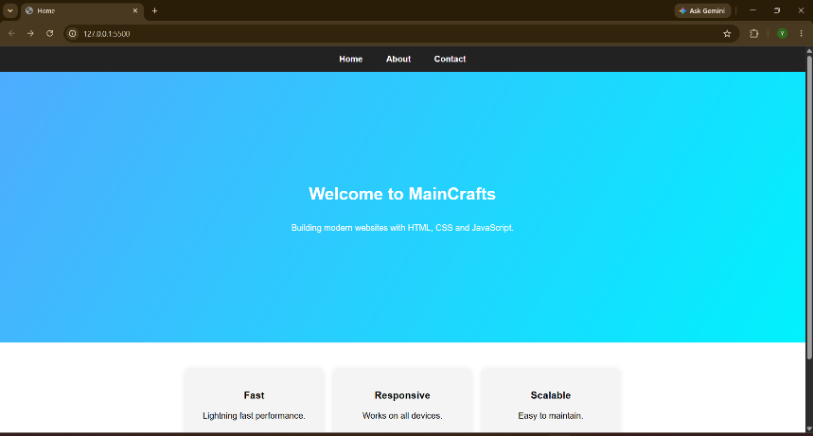
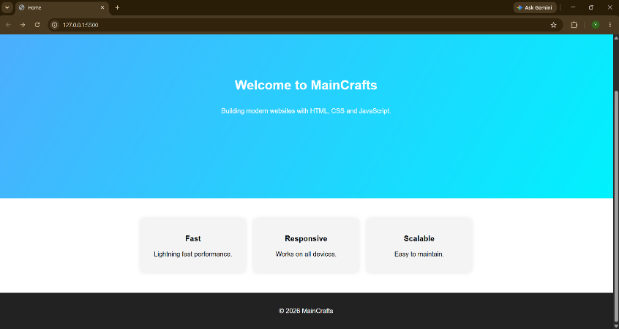
Screenshot 2 – About Page
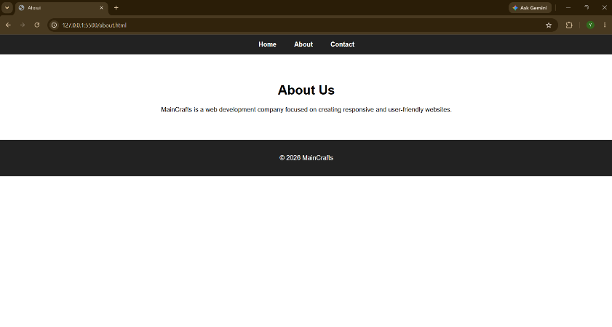
Screenshot 3 – Contact Page
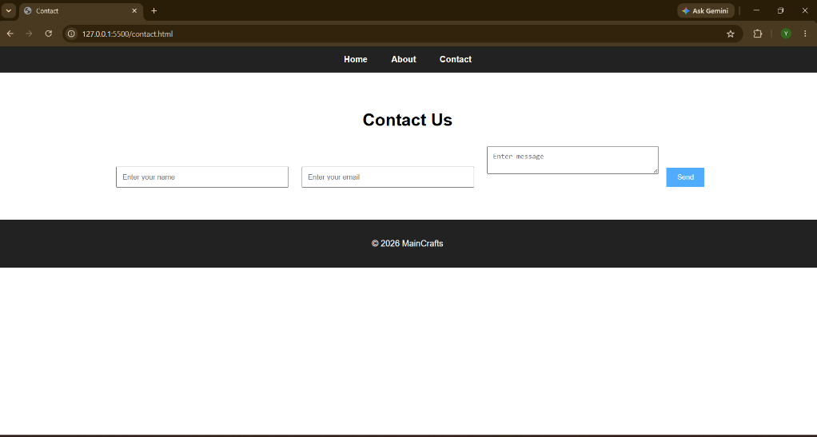
Screenshot 4 – Form Validation Output
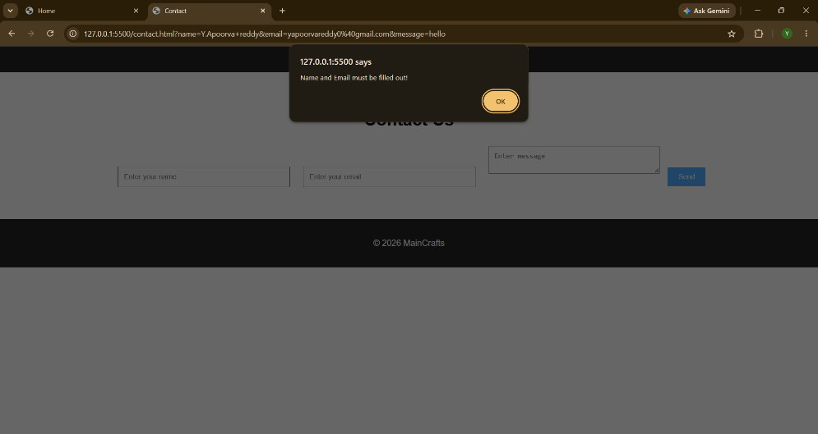
8. GitHub Repository Link
https://github.com/Apoorvareddy01/multi-page-website

10. Conclusion
This project was very helpful in understanding the fundamentals of web development. It provided practical experience in creating a multi-page website using HTML, CSS, and JavaScript. Through this task, I learned how to structure web pages, design responsive layouts, create navigation menus, and implement form validation. I also gained experience in using GitHub to upload and manage project files.
Overall, this project improved my web development skills and gave me confidence in building interactive and user-friendly websites.

